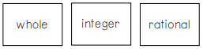
Name: __________________________________ Classifying Numbers Mystery Patterns!
Determine the three colors you are using, color the key, and then color each block according to the classification of the number: whole, integer, or rational.

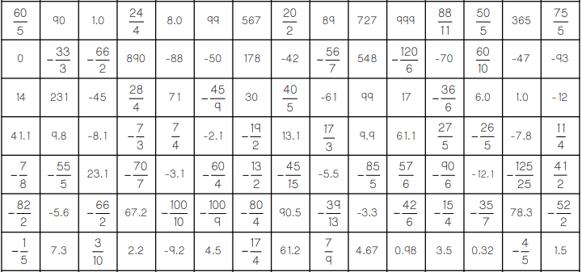


Name: __________________________________ Classifying Numbers Mystery Patterns!
Determine the three colors you are using, color the key, and then color each block according to the classification of the number: whole, integer, or rational.



